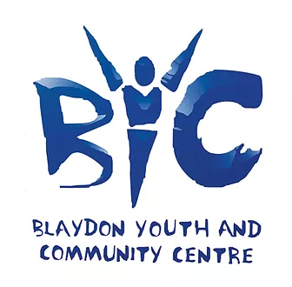
________________________

COMPLAINTS PROCEDURE
________________________

- Purpose:

The purpose of this procedure is to provide guidance on dealing with a complaint. One of the ways in which we can continue to improve our service is by listening and responding to the views of our members, customers and stakeholders, and in particular by responding positively to complaints, and by putting mistakes right. The formal complaints procedure is intended to ensure that all complaints are handled fairly, consistently and wherever possible resolved to the complainant’s satisfaction.

- Scope:

This procedure applies to all Blaydon Youth & Community Centre staff.

- Responsibilities:

BYCC’s responsibility will be to:

- acknowledge the formal complaint in writing;
- respond within a stated period of time;
- deal reasonably and sensitively with the complaint;
- take action where appropriate.

Complainant’s responsibility will be to:

- bring their complaint, in writing, to BYCC’s attention, normally within 8 weeks of the issue arising;
- raise concerns promptly and directly with a member of staff in BYCC;
- explain the problem as clearly and as fully as possible, including any action taken to date;
- allow BYCC a reasonable time to deal with the matter;
- recognise that some circumstances may be beyond BYCC’s control.

Confidentiality: Except in exceptional circumstances, every attempt will be made to ensure that both the complainant and BYCC maintain confidentiality. However, the circumstances giving rise to the complaint may be such that it may not be possible to maintain confidentiality (with each complaint judged on its own merit). Should this be the case, the situation will be explained to the complainant.

- Procedure:

Formal Complaints Procedure

Stage 1

In the first instance, if you are unable to resolve the issue informally you should write to the member of staff who dealt with you, or their manager, so that he or she has a chance to put things right.

You can expect your complaint to be acknowledged within 4 working days of receipt. You should get a response and an explanation within 15 working days. If you are unsure which member of BYCC staff to write to, your complaint should be sent to the Chief Executive.

Stage 2

If you are not satisfied with the initial response to the complaint, then you can write to BYCC’s Chair and ask for your complaint and the response to be reviewed. You can expect the Chair to acknowledge your request within 4 working days of receipt and a response within 15 working days.

BYCC’s aim is to resolve all matters as quickly as possible. However, inevitably some issues will be more complex and therefore may require longer to be fully investigated. Consequently, timescales given for handling and responding to complaints are indicative. If a matter requires more detailed investigation, you will receive an interim response describing what is being done to deal with the matter, and when a full reply can be expected and from whom.

Final Stage

If you are not satisfied with the subsequent reply from BYCC’s Chair, then you have the option of writing to the Charity’s Commission (www.charitycommission.gov.uk).

An Internal Complaints Monitoring Form must be completed for each individual case.

- Monitoring and Compliance:

The effectiveness of the procedure will be reviewed on a regular basis by the Manager (or his/her nominee).

